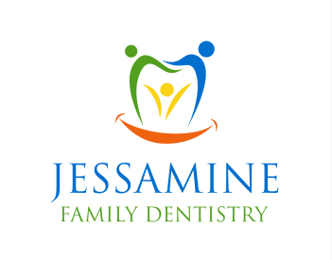
1. Do you consider yourself to be a Proactive person? Someone who likes to avoid complications. Who’d rather take care of an issue today instead of letting it worsen over time which might cost more time, visits, money, and/or pain to fix down the road?
O Yes O No
2. Do you consider yourself more of a Reactive person? Someone who would rather wait and deal with any issues as they develop. Even if it means costing you more time, visits, money, and/or pain to fix down the road?
O Yes O No
3. What do you Most Value in a dental office?
- Cosmetic - You most value how teeth look. You want them straight, white.
- Function - You most value an ability to enjoy your favorite food and drink.
- Comfort - You most value NOT being in pain or having sensitive teeth or gums.
- Longevity - You most value the ability to have your natural teeth forever.
4. What is the Biggest Obstacle you have to visiting a dental office?
- No obstacles - I come faithfully every 6 months and value my dental health
- Fear - Fear of pain, noises, environment, past experiences
- Time - Tight schedule. Not being able to get off work, getting in and out of the office quickly
- No Urgency - Nothing really hurts so I haven’t seen the need to go to the dentist.
- Budget - I knew I needed a lot of work but didn’t have the money to address the issues found.
- No Trust - Bad previous experience with my previous dentist. Felt ripped off. Did not see the need for treatment that was recommended.

